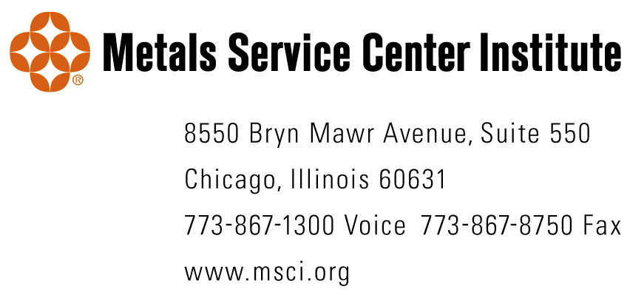

Chapter Name Change Procedure

To change the name of your chapter to Metals Service Center Institute from Steel Service Center Institute, follow the procedures below. As always, with any changes to your chapter’s governing documents, be sure to involve your attorney to ensure correct changes have been made before the Articles of Incorporation or any document are filed with government agencies.

- Change the word “steel” to “metals” in the appropriate phrases in the chapter’s Articles of Incorporation or Charter following the amendment procedures in the document.

- Change the word “steel” to “metals” in the appropriate phrases in the chapter’s By-Laws following the amendment procedures in the document.

- File the amended Articles of Incorporation or Charter with the appropriate government office in the state in which you are incorporated (check with your attorney for the exact filing procedures).

- After the state of incorporation has accepted the amended Articles of Incorporation or Charter file a name change with the Internal Revenue Service so that the Chapter’s Employer Identification Number (EIN) is associated with the correct name.

- Change the chapter’s name on all bank and investment accounts and anywhere else where the official name of the chapter must be correctly recorded.

