***2021 MSCI NEW ENGLAND CHAPTER SCHOLARSHIP GOLF OUTING***

***IN MEMORY OF PETE SPENGLER***

**A note from Sue Spengler…**

The MSCI has hosted a scholarship golf outing in honor of my husband, Pete Spengler, since 2005. Peter believed strongly in taking personal responsibility for your life and working hard to become self-sufficient. He would have been very grateful and proud to have his name associated with an effort to help young people attain the educational opportunities they need to make successful lives for themselves.

I have been able to attend many of these outings over the years, and it is always a pleasure to see those people who were there when Pete was a member. His association with those people he worked with was a rewarding experience for him and provided him with some wonderful memories.

I want to extend my congratulations and best wishes to the eight recipients of this year’s scholarships. Pete always felt that it wasn’t necessary to be the smartest guy in the room, as long as you had the best work ethic. You are at the start of a path to successful and fulfilling lives. Peter would tell you to “make the most of your opportunities.”

Sue Spengler, June 17, 2018

**MEET OUR 2021 MSCI NEW ENGLAND CHAPTER SCHOLARSHIP WINNERS:**

Brenden Baiardi:

Brenden Baiardi will be studying International Maritime Business and playing baseball at Massachusetts Maritime Academy. He chose to study International Maritime Business, because he feels it is a major part in how our economy runs in America. In his free time, Brenden enjoys coaching youth baseball and making pizzas with his family. He’s excited for his new adventure at MMA this fall!

Kimberly Berardis:

Kimberly is entering her third year at the University of Connecticut where she is enrolled in a six-year Doctor of Pharmacy (Pharm.D.) program. At school, she has the privilege of connecting with other students through her involvement as a resident assistant and as an organic chemistry tutor. After graduation, she aspires to work in either a clinical or retail pharmacy setting. Kimberly looks forward to developing meaningful relationships with patients and providing personalized patient care as a pharmacist. Her hobbies include playing chess and pickleball, swimming and reading.

Jonathan Conte:

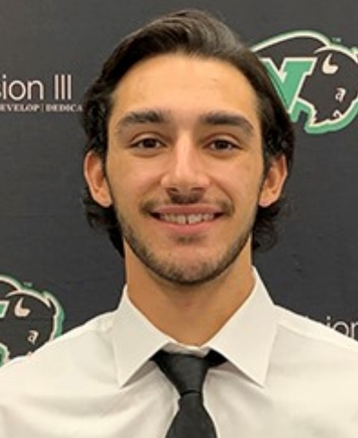

Jonathan’s goal is to become a football coach at the professional or collegiate level. At Nichols College, Jonathan is working toward his Bachelor of Science in Business Administration, with a concentration in Sport Management. Jonathan is a junior this fall and will be playing a new position on the football team (Defensive Back instead of Quarterback). He also plans to participate in the 4+1 program at Nichols to receive his master’s degree. Go Bison!”

Lauren Fernandes:

Lauren is enrolled at UMASS and is participating in the Isenberg Business program. Lauren looks forward to using her business skills, and in her free time, she enjoys hiking and cooking.

Brooke Fitzgerald:

Brooke is excited to be continuing her education at the University of Miami. She will be studying Biochemistry and Nutrition, with the goal of going to medical school to become an ophthalmologist. When she's not studying, Brooke has a passion for cheerleading and is looking forward to pursuing this further at the collegiate level.

Lauren Fitzgerald:

Lauren is looking forward to receiving her Bachelor of Music in Musical Theatre from Manhattan School of Music. With her music degree in hand, Lauren plans to pursue a career in the performance industry. In high school, outside of the performing arts, Lauren enjoyed mock trial and computer science, and she plans to continue her dance, piano and voice hobbies.

Morgan Labbe:

Morgan would like to thank the MSCI New England Chapter for the generous scholarship.

Jason Ripley:

Jason is attending the University of Hartford as an architectural design major.

In his spare time, Jason enjoys spending time with friends and playing video games; he also enjoys classic cars.