
New York Chapter

REGISTRATION FORM

December Luncheon – On Long Island, NY!

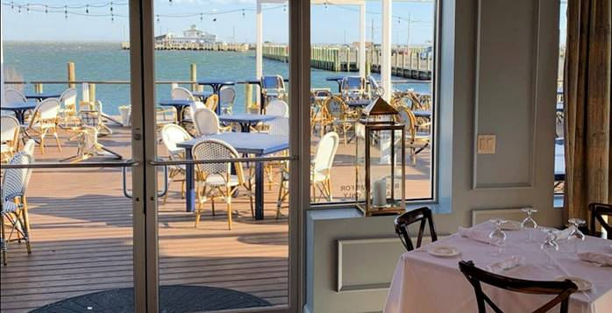

Thursday December 2, 2021, 12:00 noon
The Lakehouse Restaurant, 135 Maple Ave, Bayshore, NY 11706
631-666-0995
$80.00 Members $95.00 Non -Members
Please RSVP by November 18, 2021

Name & email: _______

Name & email: _______

Name & email: _______

Name & email: _______

Company:

Address

City State Zip

Phone Fax:

Special dietary or physical needs:

Payment:
□ Enclosed is a check payable to the MSCI New York Chapter for $_____________

Return Form with Payment to:
MSCI New York Chapter
Attn: Jennifer Chiappane
Yarde Metals Inc
603 Murray Road, East Hanover, NJ 07936
Email: Jennifer.Chiappane@Yarde.com
Phone: (973) 434-0022 / Fax: 860-406-6421

