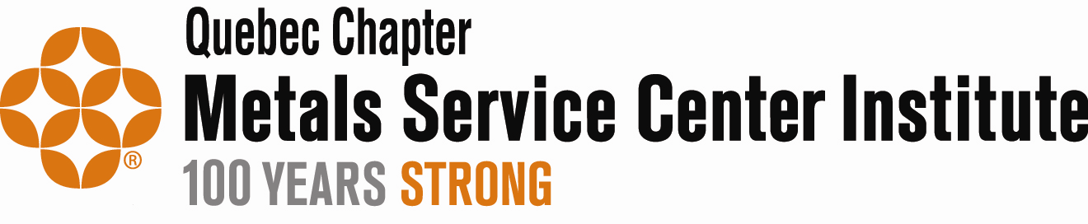

2022 Scholarship Program

Is your child college bound or currently enrolled in college? If so, he or she could receive a scholarship!


Visit
https://www.msci.org/quebec/
For more information or to print an application.

Deadline: May 31, 2022

To qualify, the applicant must be a child of an employee of a MSCI Quebec Chapter member company. Application forms include deadlines, eligibility requirements and other related information.

