

MSCI Man/Sask 7th Annual Golf Tournament

Fundraising for the future

Date: June 23, 2022

Location: Larters Golf and Country Club

30 River Road, St Andrews, MB.

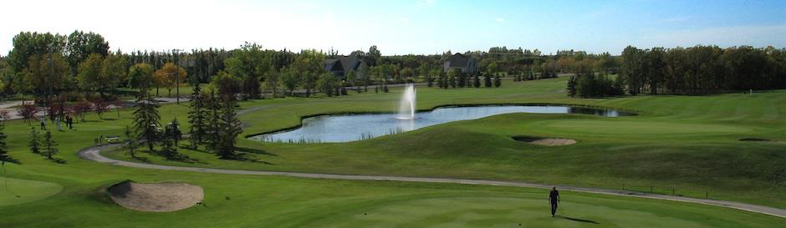

Registration at 11:00 am

Includes BBQ lunch 11:20 AM

Shotgun Start 12:00 pm

Dinner 5:30 PM

Cost $250.00 Members/ $285.00 non members

Dinner only $100.00

Please email registrations to [rslipec@asaalloys.com](mailto:rslipec@asaalloys.com) by May 20, 2022

Space Is limit so act fast!



Company Name: ______________________

Name Company Cost

1. ___________ ___________ $__________
2. ___________ ___________ $__________
3. ___________ _____________ $___________
4. ___________ _____________ $___________
5. Dinner Only Guest _____ x $100.00 $___________
6. Hole Sponsorship _____ x 250.00 $___________

Members wishing to be invoiced for the tournament fees, please sign below and email to rslipec@asalloys.com

Sign__________________ Date___________

Checks are payable to MSCI Man/Sask Chapter and mailed to

ASA Alloys 61 Paramount Road, Winnipeg, MB. R2X 2W6

Attn Rhonda

All payments due by date of the event



MSCI Sponsor a Hole Scholarship Program

Cost 250.00 per hole

Signage will be provided by the MSCI

Please email logos to Darryl.Funk @Samuel.com

