Jeffrey J. Moskaluk
Senior Vice President, Chief Commercial Officer
SSAB Americas
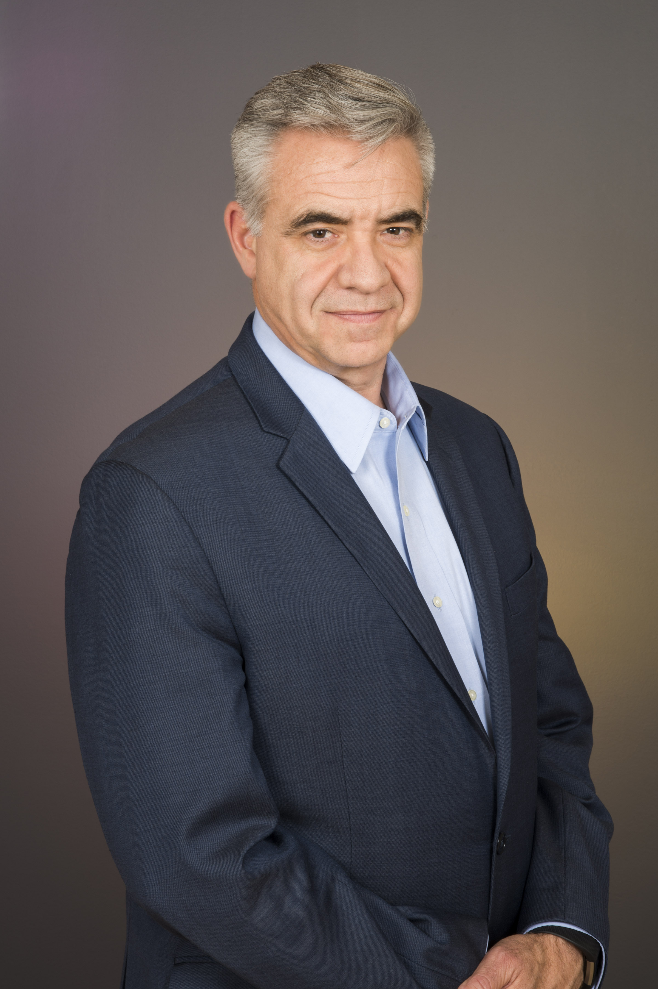
Jeff Moskaluk is senior vice president and chief commercial officer of SSAB Americas, a leading steel plate producer in North America. SSAB operates two steel mills located in Montpelier, IA and Mobile, AL, together with three cut-to-length processing facilities located in Houston, TX; St. Paul, MN; and Toronto, ON.

Jeff started his career in the steel Industry in 1984 and joined SSAB (formerly IPSCO) in July 1990. During his more than 30 years at SSAB and its predecessors, Jeff has held various positions, each with increasing responsibility, in the following business areas; Sales, Marketing, Operations, Business Planning, Government Relations, Trade and Communications.

In September 2011, Jeff was promoted to the role of vice president and chief commercial officer, and in October of 2017 was named senior vice president. Jeff's current responsibilities include oversight of SSAB Americas’ business unit teams and oversight of SSAB Americas commercial activities. Jeff’s commercial oversight includes; commercial product sales, commercial marketing, sustainability marketing, trade, sales information and commercial strategy.

Jeff remains an active participant in various steel industry associations, including current and past participation in the following; American Iron and Steel Institute, Steel Market Development Institute, Metals Service Center Institute, American Institute for Steel Construction, Canadian Institute for Steel Construction, Steel Structures Education Foundation, Toronto Steel Buyers and Associates, and the Association of Women in the Metal Industries.

Jeff attended Wilfrid Laurier University in Waterloo, Ontario and graduated with a bachelor’s degree and a graduate diploma in Business Administration.

Jeff is located out of SSAB Americas’ offices in Mobile, AL.

