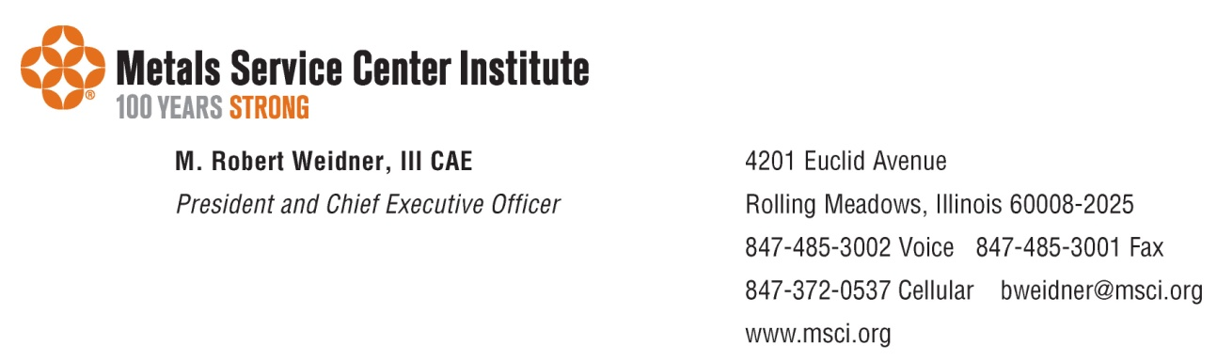

October 5, 2023

Federal Trade Commission

Office of the Secretary

600 Pennsylvania Avenue NW

Suite CC–5610

Washington, DC 20580

**RE: Petition for Rulemaking of the U.S. Chamber of Commerce**

We write in support of the U.S. Chamber of Commerce’s petition to initiate a rulemaking to revise the rule regarding disqualification of Commissioners (16 C.F.R. §4.17) and to establish procedures for disqualification of Commissioners in response to a request for recusal.

The FTC has recently embarked on a series of rulemakings and launched cases challenging established law through its internal administrative proceedings. Because the agency occupies a powerful position in the federal government – often operating as a rule maker, prosecutor, and judge – it is important that our members trust the FTC’s decision-making process is free from bias. The existence of bias, or even the mere appearance of it, leaves agency decisions vulnerable to judicial challenge. Therefore, recusal rules should be clear and comprehensive.

The FTC’s current recusal rules, however, leave much about the decision process in a black box. This lack of transparency raises concerns about the integrity of the FTC’s administrative process for our members. The FTC should have recusal standards that offer some criteria to guide Commissioners and avoid conflicts of interest. The U.S. Chamber of Commerce’s petition offers simple, yet effective changes to ensure due process and transparency.

The FTC long relied on informal procedures when addressing recusal motions. As the agency embarks on an ambitious rulemaking and enforcement agenda, our members support a more formal recusal process. Modest changes to the recusal process ensure that potential conflicts of interest are fully considered. The rulemaking petition should be accepted.

The [Metals Service Center Institute](https://www.msci.org/) (MSCI) provides vision and voice to the metals industry, along with the tools and perspective necessary for a more successful business. We offer our service centers, producing mills, and affiliate members an impressive array of high-level programs and services. Our goal is to meet their needs for knowledge and thought leadership, provide data and education for operational efficiency, promote industry advocacy, and create a marketplace for efficient transactions, debate, discussion and learning.

Thank you for your attention to this crucial issue.

Bob Weidner

M. Robert Weidner, III  
MSCI President & CEO