**Application deadline is   
April 1, 2024**



**Is your child college bound or already in college?  
If so, he or she could receive a scholarship!**

In 2024, the MSCI Northern Ohio Chapter scholarship committee will be awarding up to (14) $2,500 scholarships. To qualify, the applicant must be a child/spouse of an employee of an MSCI Northern Ohio Chapter member company; must have been accepted by and/or currently attending either a technical/career school or two- or four-year degree program.

**Visit** [**http://scholarships.msci.org/**](http://scholarships.msci.org/)

**for more information and to complete the online application!**

COLLEGE

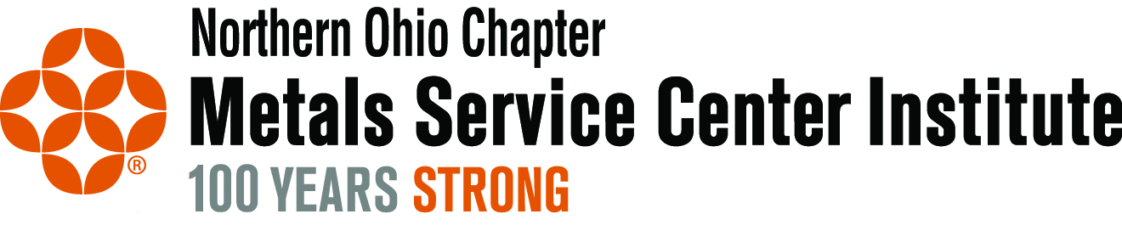

SCHOLARSHIPS