MSCI Manitoba/Saskatchewan Chapter 11th Annual Golf Tournament
FUNDRAISING FOR THE FUTURE
Date: Tuesday, June 16, 2026
Location: Larters Golf and Country Club 30 River Road, St Andrews, MB.
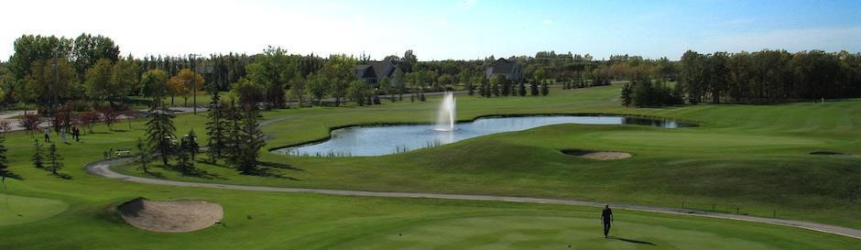

Registration @ 11:00 am
Includes Food Station Lunch Starting @ 11:20 AM (Pulled Pork On A Bun With Coleslaw) Shotgun Start @ 12:00 pm
Dinner @ 5:30 PM (AAA Angus Prime Rib Dinner)
Cost $350.00 MSCI Members & Guests / $400.00 Non-Members (Per Golfer) Dinner Only $150.00 (Per Person)

Please E-mail Registrations To rslipec@asaalloys.com By May 15, 2026
Space Is Limited, So Act Fast!!!

Company Name:
Name Company Cost

1) |  | $
2) |  | $
3) |  | $
4) |  | $
5) Dinner Only Guest | x $150 | $
Hole Sponsorship:
- Hole Sponsor Member x $300 $
- Hole Sponsor Non-Member x $400 $

Members wishing to be invoiced for the tournament fees, please sign below and email to rslipec@asaalloys.com

Sign Date

Checks are payable to MSCI Man/Sask Chapter and mailed to ASA Alloys 61 Paramount Road, Winnipeg, MB. R2X 2W6 Attn: Rhonda Slipec
All Payments Are Due By Date Of The Event

MSCI Sponsor a Hole Scholarship Program

Members @ $300.00/hole Non-Members @ $400.00/hole

Signage Will Be Provided By The MSCI

Please E-Mail Logos To Neil.Ritter@Encoremetals.com

Those wishing to donate items for the “Silent Auction”, please advise by email Neil.Ritter@Encoremetals.com by no later than June 2, 2026. See attached request.

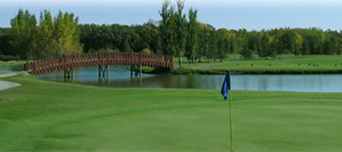

March 25, 2026
Greetings Fellow Supporters of the Metal Service Center Institute,

The MSCI MB/SK Chapter's 10th Annual Golf Tournament is fast approaching, and we are seeking your support for our fundraising efforts. For 2026, we will be holding a “Silent Auction” raffle draw and are in need of prize donations, both big and small, to help raise additional funds for our scholarship program.

Over the past 11 years, our fundraising activities have provided over 150 scholarships totaling $232,500 to deserving children of our industry members.

Your generous donations will be recognized at our event, showcasing your valuable participation.

If you wish to contribute to our event, please contact Neil Ritter at Neil.Ritter@Encoremetals.com or via mobile at 431-791-4340 to make arrangements. We kindly ask for all donations to be submitted on or before June 5th to help us prepare for our event on June 16, 2026.

Thank you for your continued support.
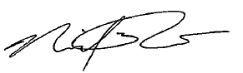
Neil Ritter
President
Metals Service Center Institute
Manitoba/Saskatchewan Chapter
Neil.Ritter@Encoremetals.com
431-791-4340



